# Sustainable Smart City Assistant - Technical Architecture

This document provides a detailed technical architecture overview of the Sustainable Smart City Assistant, an AI-powered platform designed to support urban sustainability, governance, and citizen engagement using IBM Watsonx Granite LLM.

## 1. Architecture Overview

The platform integrates multiple components including a Streamlit frontend, FastAPI backend, and external services like IBM Watsonx and Pinecone. These components work together to process data, provide insights, and deliver a seamless user experience.

## 2. Frontend: Streamlit

The user-facing interface built with Streamlit enables interaction with the assistant. Users can:  
- View & submit KPIs  
- Interact with the Chat Assistant  
- Submit citizen feedback  
- Search policy documents  
- Get eco tips

## 3. Backend: FastAPI

The FastAPI backend acts as the middleware connecting frontend actions with AI and ML services. It is responsible for:  
- Handling file uploads (e.g., PDFs, CSVs)  
- Integrating and serving ML models  
- Generating predictions and analytics

## 4. External Services

The system integrates powerful external services for advanced capabilities:  
  
1. IBM Watsonx Granite LLM:  
- Policy summarization  
- Chat assistant responses  
- Report generation  
  
2. Pinecone Vector DB:  
- Semantic policy/document search using vector embeddings  
  
3. Local/Hosted Data Stores:  
- Storing structured and unstructured data (e.g., historical KPIs)

## 5. Data Flow Summary

1. User submits data or queries through Streamlit.  
2. FastAPI routes the request, handles files, and invokes ML models.  
3. External services (Watsonx, Pinecone) are triggered as needed.  
4. Processed data is returned to the frontend for user display.

## 6. Architecture Diagram

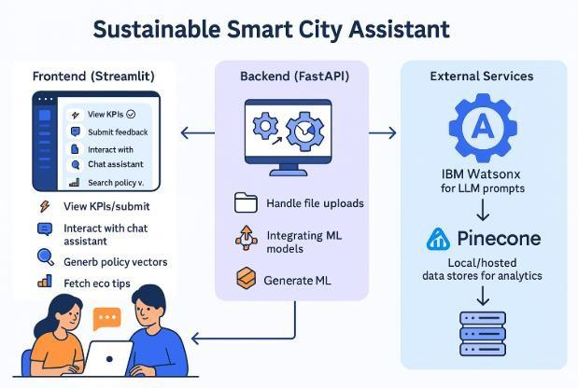

Figure: Technical architecture of the Sustainable Smart City Assistant